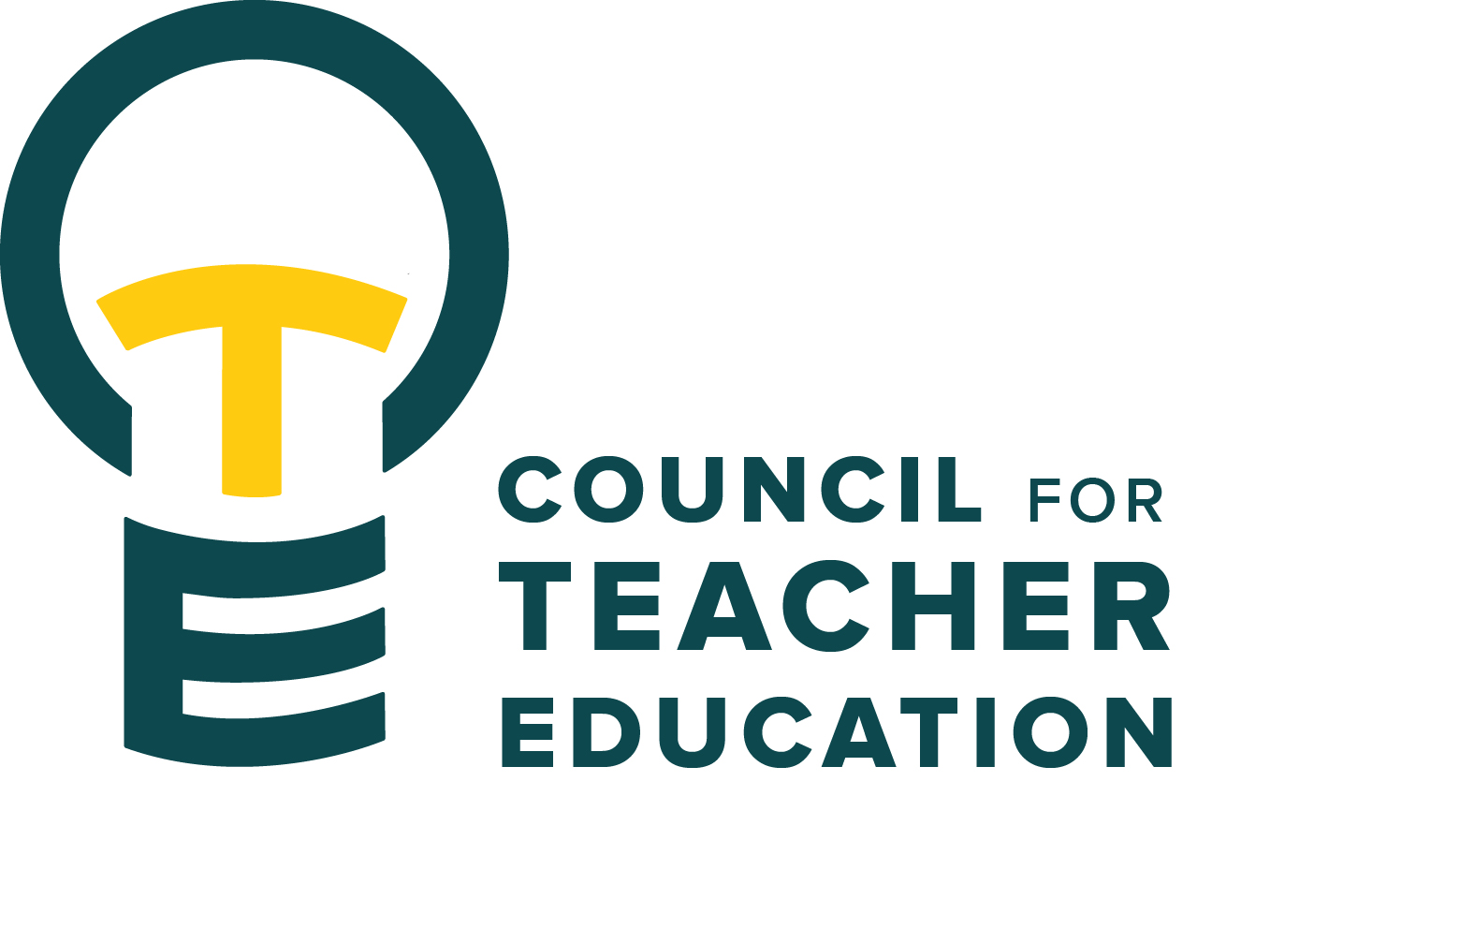

Council for Teacher Education
Meeting Agenda
January 27, 2026, 3:00-4:30 pm, DeGarmo 551
- Call to order
- Roll Call (In Attendance & Absent)
- Approval of minutes from the December 9th meeting:
- Information Items:
  - ISU Redbird Educator Advocacy Day, Wednesday Feb. 25, RSVP to reserve your spot on the bus
- Subcommittee Reports:
  - Curriculum (Rocio Rivadeneyra)
  - Advocacy (Jay Percell & Bryan Zugelder)
  - Student Advocacy & Interests (Mary Tackett & Sara Piotrowski)
  - University Educator Preparation Program Assessment and Reporting (Sarah Boesdorfer)
- Discussion Items:
  - Peggy Finnegan-Boyes, TEC Data & Assessment Coordinator
  - Terry Jackson, TEC Data & Placement Coordinator
  - Kelli Appel, Director of Recruitment, Retention, and Student Services, College of Education
- Action Items:
- Legislative Updates:
- Announcements and Last Comments:
- Adjournment:

Next CTE Executive Board Meeting: February 3, 2026, 2-3 pm
Next CTE Subcommittee Meetings: February 3, 2026, 3:00-4:30 pm
Advocacy - Co-Chairs Jay Percell & Bryan Zugelder (DEG 506A 3:00-4:30)
Curriculum – Chair Rocio Rivadeneyra (DEG 304 3:00-4:30)
Student Advocacy & Interests – Co-Chairs Mary Tackett & Sara Piotrowski (DEG 504 3:30-4:30)
University Educator Preparation Program Assessment & Reporting – Chair Sarah Boesdorfer (DEG 551 3:00-4:30)
Next CTE Meeting: February 24, 2026, 3:00-4:30 pm

2025-2026 CTE & COMMITTEE MEETING SCHEDULE
CTE DEG 551 | 2026 Exec & Subcommittees | 2026 Exec & Subcommittees: continued
Feb. 24 | Feb. 3 | Mar. 17
Mar. 24 | Feb. 17 | Apr. 7
Apr. 28 | Mar. 3 | Apr. 21

