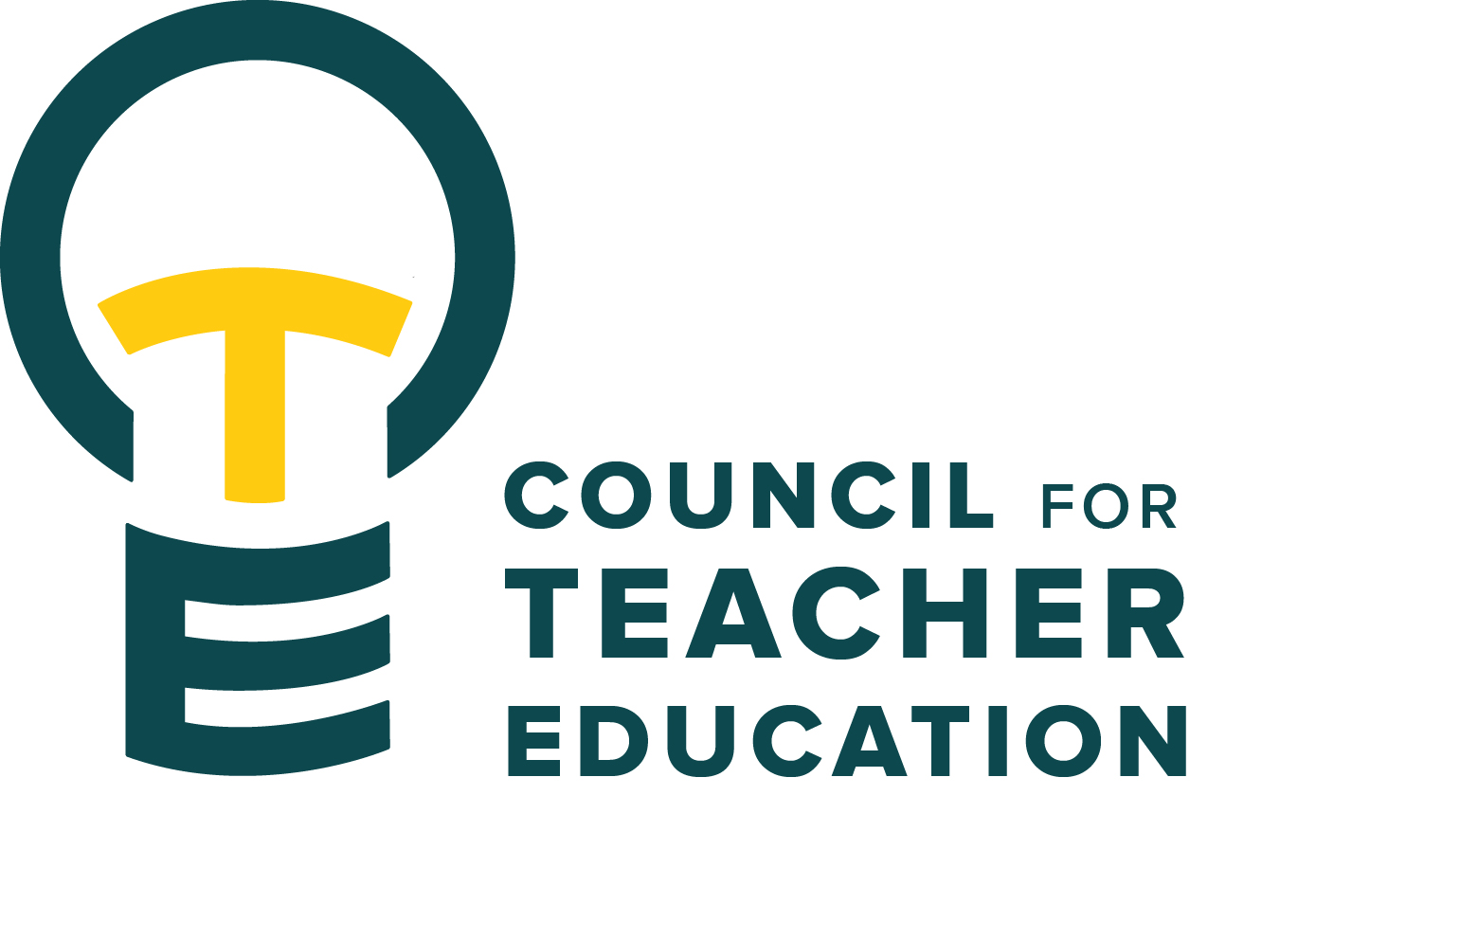

Council for Teacher Education
Meeting Agenda
February 24, 2026, 3:00-4:30 pm, DeGarmo 551
- Call to order
- Roll Call (In Attendance & Absent)
- Approval of minutes from the January 27th meeting:
- Information Items: Katie Raisner, CAS Director of Student Success klraisn@ilstu.edu
- Subcommittee Reports:
  - Curriculum (Rocio Rivadeneyra)
  - Advocacy (Jay Percell & Bryan Zugelder)
  - Student Advocacy & Interests (Mary Tackett & Sara Piotrowski)
  - University Educator Preparation Program Assessment and Reporting (Sarah Boesdorfer)
- Discussion Items:
  - Advocacy Subcommittee reporting out on the December full CTE discussion about what it means to be a redbird educator.
- Action Items:
- Legislative Updates: Brad Franke, Director of Public Affairs & Policy, Website: Government Relations | Office of the President | Illinois State & Jon Pyatt with Mercury
- Announcements and Last Comments:
- Adjournment:

Next CTE Executive Board Meeting: March 3, 2026, 2-3 pm
Next CTE Subcommittee Meetings: March 3, 2026, 3:00-4:30 pm
Advocacy - Co-Chairs Jay Percell & Bryan Zugelder (DEG 506A 3:00-4:30)
Curriculum – Chair Rocio Rivadeneyra (DEG 304 3:00-4:30)
Student Advocacy & Interests – Co-Chairs Mary Tackett & Sara Piotrowski (DEG 504 3:30-4:30)
University Educator Preparation Program Assessment & Reporting – Chair Sarah Boesdorfer (DEG 551 3:00-4:30)
Next CTE Meeting: March 24, 2026, 3:00-4:30 pm

2025-2026 CTE & COMMITTEE MEETING SCHEDULE
CTE DEG 551 | 2026 Exec & Subcommittees | 2026 Exec & Subcommittees: continued
Feb. 24 | Feb. 3 | Mar. 17
Mar. 24 | Feb. 17 | Apr. 7
Apr. 28 | Mar. 3 | Apr. 21

