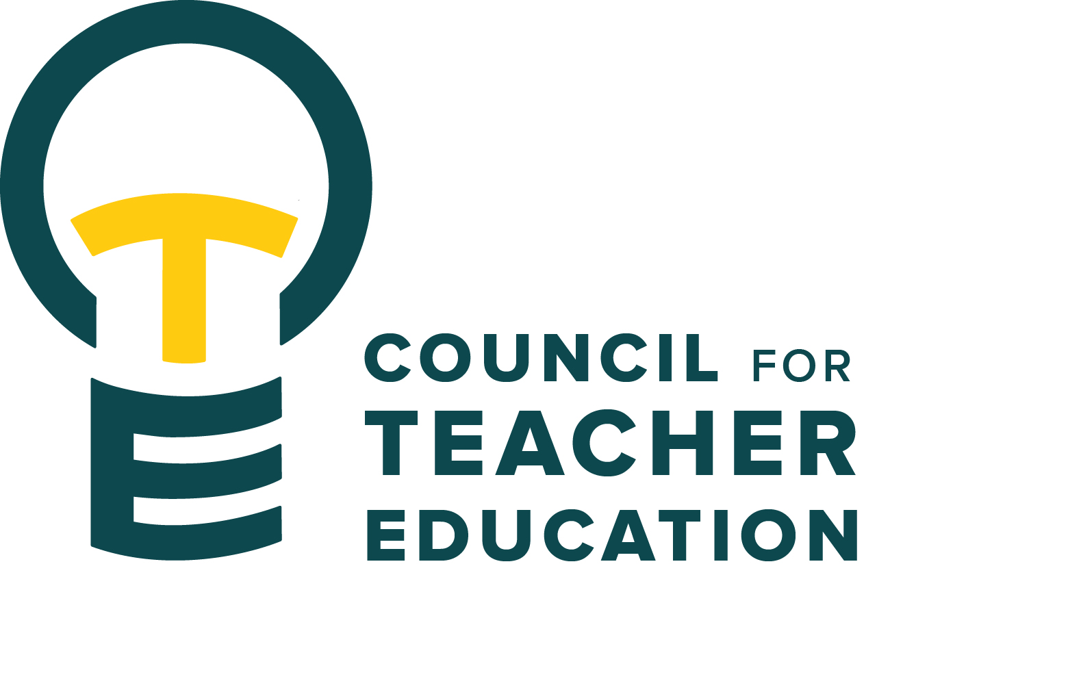

Council for Teacher Education
Meeting Agenda
March 24, 2026, 3:00-4:30 pm, DeGarmo 551
- Call to order
- Roll Call (In Attendance & Absent)
- Approval of minutes from the February 24th meeting:
- Information Items:
  - ESLAB, introduction & overview (Sahana Mathan & Ella Pettit)
  - Highpoint updates & information (Amy Hurd)
  - Review CTE membership & bylaws and recognize those completing service at the end of April 2026 (Allison Kroesch)
- Subcommittee Reports:
  - Curriculum (Rocio Rivadeneyra)
  - Advocacy (Jay Percell & Bryan Zugelder)
  - Student Advocacy & Interests (Mary Tackett & Sara Piotrowski)
  - University Educator Preparation Program Assessment and Reporting (Sarah Boesdorfer)
- Discussion Items:
  - Continue Discussion about the Redbird Educator qualities & reimagining the democratic ideal. Survey review and revision aligning to the various stakeholders. (Advocacy Subcommittee)
- Action Items:
- Legislative Updates:
- Announcements and Last Comments:
- Adjournment:

Next CTE Executive Board Meeting: April 7, 2026, 2-3 pm
Next CTE Subcommittee Meetings: April 7, 2026, 3:00-4:30 pm
Advocacy - Co-Chairs Jay Percell & Bryan Zugelder (DEG 506A 3:00-4:30)
Curriculum – Chair Rocio Rivadeneyra (DEG 304 3:00-4:30)
Student Advocacy & Interests – Co-Chairs Mary Tackett & Sara Piotrowski (DEG 504 3:30-4:30)
University Educator Preparation Program Assessment & Reporting – Chair Sarah Boesdorfer (DEG 551 3:00-4:30)
Next CTE Meeting: April 28, 2026, 3:00-4:30 pm

2025-2026 CTE & COMMITTEE MEETING SCHEDULE
CTE DEG 551 | 2026 Exec & Subcommittees
Apr. 28 | Apr. 7
 | Apr. 21

