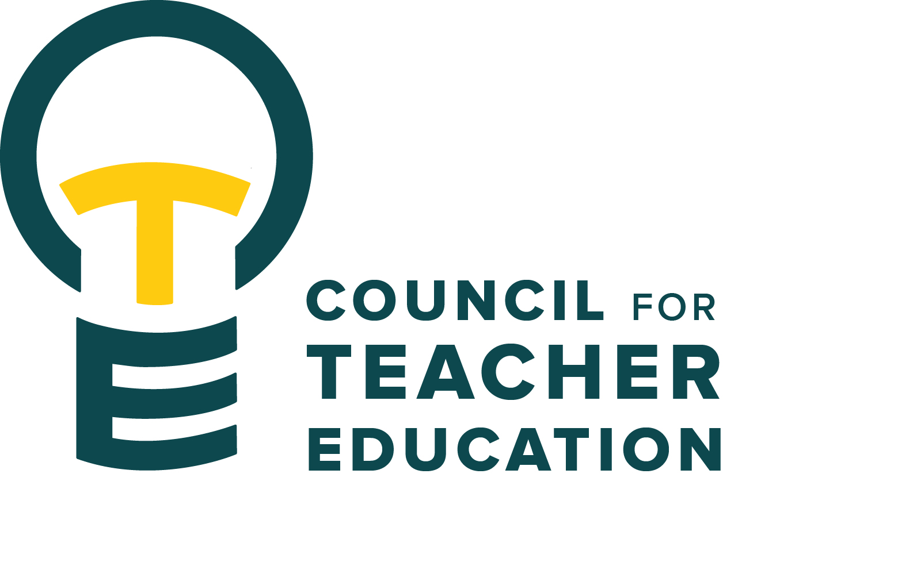

Council for Teacher Education
Meeting Agenda
April 28, 2026, 3:00-4:30 pm, DeGarmo 551
- Call to order
- Roll Call (In Attendance & Absent)
- Approval of minutes from the March 24th meeting:
- Information Items:
  - Presentation to CTE about the APIR (Sarah Boesdorfer, University Educator Preparation Program Assessment & Reporting subcommittee & Peggy Finnegan-Boyes, Teacher Education Center, Assessment Coordinator)
  - Presentation of the Student Excellence Awards (Mary Tackett, Student Advocacy & Interests subcommittee)
  - Pillars of Educator Excellence Canvas Modules, overview & updates (Becky Beucher, Efaw Center & Mary Tackett, Student Advocacy & Interests subcommittee)
  - Thank you to the student representatives, thank you to the Dean's Representatives, thank you to the CTE members for this years’ service and engagement. A special thank you to those who have served their maximum terms and to those who are leaving CTE.
- Subcommittee Reports:
  - Curriculum (Rocio Rivadeneyra)
  - Advocacy (Jay Percell & Bryan Zugelder)
  - Student Advocacy & Interests (Mary Tackett & Sara Piotrowski)
  - University Educator Preparation Program Assessment and Reporting (Sarah Boesdorfer)
- Discussion Items:
  - Review bylaws: subcommittee assignments, membership, and leadership
  - Election: CTE chair, vice chair, secretary
- Action Items:
- Legislative Updates:
  - Check out the new CTE teams folder: Legislative Updates Council for Teacher Education (CTE) - Documents - Legislative Updates - All Documents
- Announcements and Last Comments:
  - Have a great end to the semester & joyful summer. Please let Allison or Monica know if you have interest in a particular subcommittee assignment or leadership role (want to be considered as chair or co-chair).
- Adjournment:

This is the final CTE Meeting of the 2025-2026 Academic Year. We will vote online in May to approve the April 28, 2026, minutes.

Reminder:
All subcommittee chairs need to send their year-end report to Allison Kroesch and Monica Noraian. CTE is required to file an annual report with the Academic Senate.

