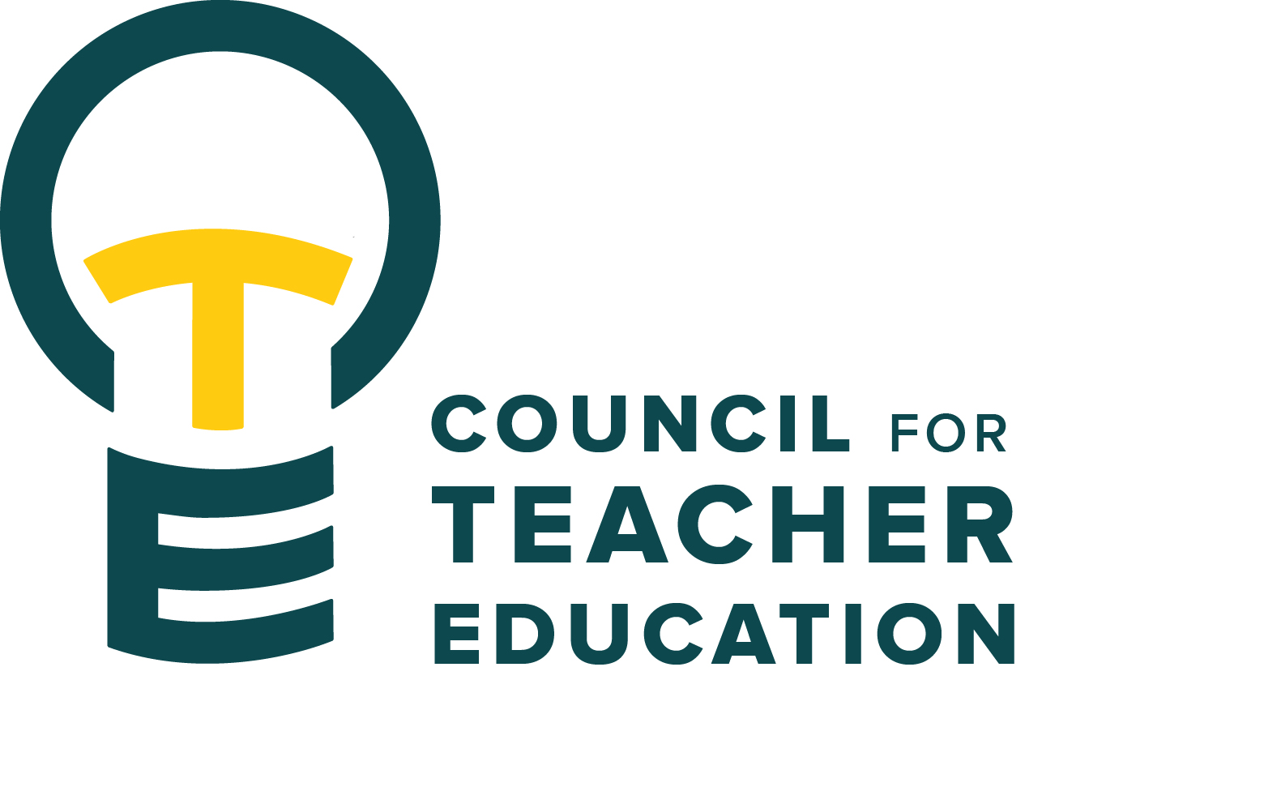

***Council for Teacher Education***

Meeting Agenda

September 23, 2025, 3:00-4:30 pm, DeGarmo 551

1. Call to order
2. Roll Call (In Attendance & Absent)
3. Approval of minutes from the August 26th meeting:
4. Information Items:
   1. Senate welcome remarks: Angie Bonnell, Chair, Academic Senate
   2. Legislative & Education Advocacy Updates:
      1. State Level - Brad Franke, Director of Public Affairs & Policy
      2. Federal Level - Jon Pyatt, Mercury
      3. Q&A
5. Subcommittee Reports: 
   1. Curriculum (Rocio Rivadeneyra)
   2. Advocacy (Jay Percell & Bryan Zugelder)
   3. Student Advocacy & Interests (Mary Tackett & Sara Piotrowski)
   4. University Educator Preparation Program Assessment and Reporting (Sarah Boesdorfer)
6. Discussion Items:
   1. Per process check in & discussion
7. Action Items:
8. Legislative Updates:
9. Announcements and Last Comments:
10. Adjournment:

**Next CTE Executive Board Meeting: October 7, 2025, 2-3 pm** (if needed)

**Next CTE Subcommittee Meetings: October 7, 2025, 3:00-4:30 pm**(if needed)

**Advocacy -** Co-Chairs Jay Percell & Bryan Zugelder (DEG 506A 3:00-4:30)

**Curriculum –** Chair Rocio Rivadeneyra(DEG 304 3:00-4:30)

**Student Advocacy & Interests –** Co-Chairs Mary Tackett & Sara Piotrowski (DEG 504 3:30-4:30)

**University Educator Preparation Program Assessment & Reporting –** Chair Sarah Boesdorfer (DEG 551 3:00-4:30)

**Next CTE Meeting:  October 28, 2025, 3:00-4:30 pm**

**2025-2026 CTE & COMMITTEE MEETING SCHEDULE**

|  |  |  |
| --- | --- | --- |
| **CTE** DEG 551 | **2025 Exec & Subcommittees** | **2026 Exec & Subcommittees: continued** |
| Aug. 26 | Aug. 19 | Jan. 6 (No Meeting) |
| Sept. 23 | Sept. 2 | Jan. 20 |
| Oct. 28 | Sept. 16 | Feb. 3 |
| Nov. 18 | Oct. 7 | Feb. 17 |
| Dec. 9 | Oct. 21 | Mar. 3 |
| Jan. 27 | Nov. 4 | Mar. 17 |
| Feb. 24 | Nov. 18 (No Meeting) | Apr. 7 |
| Mar. 24 | Dec. 2 | Apr. 21 |
| Apr. 28 | Dec. 16 (No Meeting) |  |