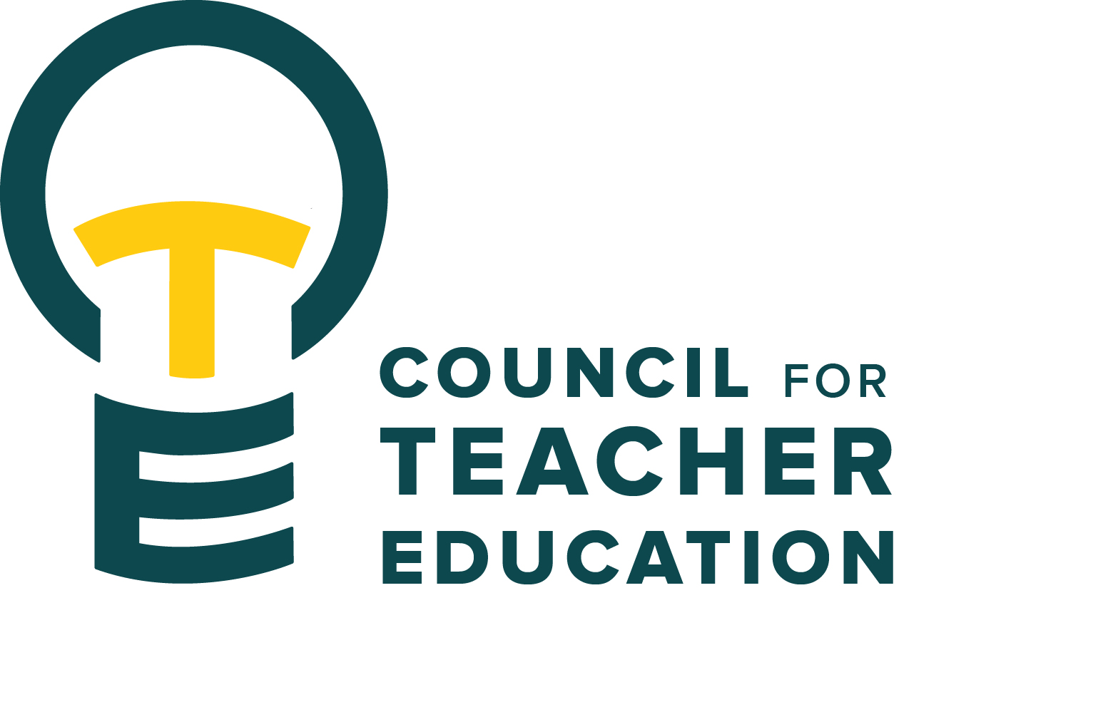

Council for Teacher Education
Meeting Agenda
November 18, 2025, 3:00-4:30 pm, DeGarmo 551
- Call to order
- Roll Call (In Attendance & Absent)
- Approval of minutes from the October 28th meeting:
- Information Items:
  - Welcome & Introductions of our newest members
  - Amy Hurd, Minors
  - Troy Hinkel, Subsequent endorsements: process & information
- Subcommittee Reports:
  - Curriculum (Rocio Rivadeneyra)
  - Advocacy (Jay Percell & Bryan Zugelder)
  - Student Advocacy & Interests (Mary Tackett & Sara Piotrowski)
  - University Educator Preparation Program Assessment and Reporting (Sarah Boesdorfer)
- Discussion Items:
  - Sharing information gathered from all Teacher Education Programs & Guest reporting out on their subsequent endorsements
  - Student Teaching Semester: exploring total semester hours, what courses beyond student teaching and changes in course codes and “home department” – bringing some consistency and increased understanding to what it looks like
  - Suggestions for future meeting topics or areas of question or concern or interest.
- Action Items:
- Legislative Updates:
- Announcements and Last Comments:
- Adjournment:

Next CTE Executive Board Meeting: December 2, 2025, 2-3 pm
Next CTE Subcommittee Meetings: December 2, 2025, 3:00-4:30 pm
Advocacy - Co-Chairs Jay Percell & Bryan Zugelder (DEG 506A 3:00-4:30)
Curriculum – Chair Rocio Rivadeneyra (DEG 304 3:00-4:30)
Student Advocacy & Interests – Co-Chairs Mary Tackett & Sara Piotrowski (DEG 504 3:30-4:30)
University Educator Preparation Program Assessment & Reporting – Chair Sarah Boesdorfer (DEG 551 3:00-4:30)
Next CTE Meeting: December 9, 2025, 3:00-4:30 pm

2025-2026 CTE & COMMITTEE MEETING SCHEDULE
CTE DEG 551 | 2025 Exec & Subcommittees | 2026 Exec & Subcommittees: continued
Dec. 9 | Dec. 2 | Feb. 17
Jan. 27 | Dec. 16 (No Meeting) | Mar. 3
Feb. 24 | Jan. 6 (No Meeting) | Mar. 17
Mar. 24 | Jan. 20 | Apr. 7
Apr. 28 | Feb. 3 | Apr. 21

