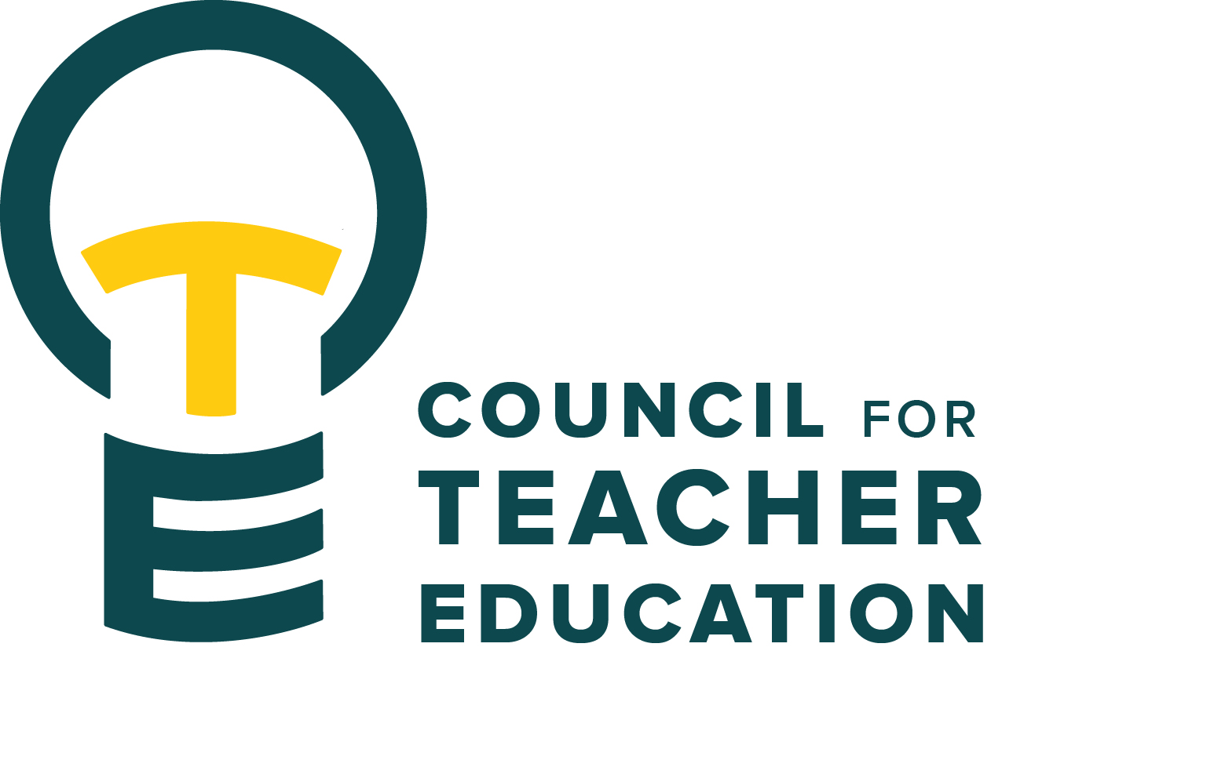

Council for Teacher Education
Meeting Minutes
January 27, 2026, 3:00-4:30 pm
Members Present: Joshua Altshuler, Aaron Baker, Sarah Boesdorfer, Gary Cates, Yojanna Cuenca-Carlino, Amanda Cullen, Cailyn Grieshaber, Md Didar Hossain, Amy Hurd, Jeongae Kang, Sonia Kline, Allison Kroesch, Beth MacDonald, Sahana Mathan, Michelle Maurer, Kathy Mountjoy, Oscar Nunez-Enriquez, Monica Noraian, Jay Percell, Rocio Rivadeneyra, Bert Stabler, Janet Tulley, Michael Young

Absent: Tyler Ellison, Cassandra Mattoon, Ishmael Neequaye, Danielle Rankin, Marcus Russell, Mary Tackett, Rudo Tsemunhu, Bryan Zugelder

Guests: Becky Beucher, Derrek Drenckpohl, Peggy Finnegam-Boyes, Gary Higham, Troy Hinkel, Terry Jackson, Heidi Olsen

- Call to order: A. Kroesch called the meeting to order at 3:01 pm
- Roll Call: K. Brown conducted a roll call.
- Approval of minutes: December 9th minutes approved unanimously with no abstentions
- Information Items:
  - ISU Redbird Educator Advocacy Day, Wednesday, Feb. 25, RSVP to reserve your spot on the bus.
  - San Antonio Student Teaching Opportunity – A valuable partner with ISU, the program has been in existence for over 30 years. Students, with their program’s approval, complete the full semester of student teaching in this Texas school district.
  - International Student Teaching – with their program’s approval, students can complete the last portion of their student teaching with one of the following international programs: Murcia, Spain; Taichung, Taiwan; Bangkok, Thailand; and now Panama City, Panama. Students complete a ten-week placement locally, and the remaining 5 weeks are spent abroad. Student costs range from approximately $3,500 to $5,000, depending on the program they select.
  - Summer Paid Teaching Internship with Ivy Collegiate Academy in Taichung, Taiwan – Dr. Shannon Perez will visit ISU during the Education Career Fair and hold two information sessions on February 18th, at 10:00 a.m. & 1:00 p.m. in the Lauby Center, DEG 56.
  - Hunter Family Trust Scholarship – for Teacher Education majors who graduate from a high school in McLean County. Awards generally range from $1,000 to over $2,000, depending on the number of qualified applicants. The application deadline is March 2, 2026.
- Subcommittee Reports:
- Curriculum Committee: R. Rivadeneyra – Curriculum Committee met and discussed 25 curriculum proposals.
- 2 from Business Education that we sent back for more information
- 13 from TCH. All graduate classes and 1 new certificate
- 5 from Communication Sciences and Disorders. New or revised courses in SLP program
- 5 from Special Education
- The curriculum committee moves to approve a new graduate certificate for English as a Second Language that is meant for already licensed teachers. B. MacDonald motioned to move the new certificate to a vote, and J. Percell seconded the motion. All members present were in favor; the motion passed.
- Advocacy Committee: J. Percell – The group will review data gathered regarding what it means to be a Redbird Educator. Jay expressed his thanks to Monica and Becky for their work on the Redbird Advocacy Day in Springfield. The Aspiring Educators and Office of Civic Engagement will be tabling on the 1st Floor of DeGarmo on February 11th & 18th to gather personal stories from students and faculty relating to specific Teacher Education legislation. Postcards with this information will be shared with legislators.
- Student (Advocacy &) Interest Committee: M. Tackett – Shared by A. Kroesch – The student excellence award theme this year is Equity in Action: Creating Pathways for All Learners. Five $1000 scholarships will be awarded. Submissions should address, but are not limited to, persistent disparities in access, outcomes, and resources—especially for low-income, ELL, and disabled students—demand intentional, equity-focused teaching. Lessons should reflect differentiated instruction, universal design for learning (UDL), inclusive technology use, and/or community-based learning.
Due date: Email to the CTE Student Interests Subcommittee Co-Chairperson, Dr. Sara Piotrowski (scpiotr@ilstu.edu) by Tuesday, March 24th, at 11:59 p.m.
- University Educator Preparation Program Assessment & Reporting Committee: S. Boesdorfer – Reminded members that the APIRs are due February 20th.
- Discussion Items:
  - Terry Jackson, TEC Data & Placement Coordinator and Peggy Finnegan-Boyes, TEC Data & Assessment Coordinator each reviewed various data points and approaches to program data review. To continue building a culture of data assessment and data-informed decision-making in ISU Teacher Education, Assessment Conversations/Workshops will be held on February 12, from 2-3:30 pm, and February 13, from 11 am -12:30 pm in the Lauby Center. Peggy has sent a link via Signup Genius.
  - Kelli Appel, Director of Recruitment, Retention, and Student Services, College of Education, shared highlights of recruitment activities taking place. During visits with prospective students, she will often share informational flyers developed for individual programs within Teacher Education. CTE members were encouraged to review their flyers for any necessary edits. Kelli shared an informational flyer for the Teacher of Illinois Scholarship Program. Recipients of this award must have attended a high school with a high vacancy rate.
- Action Items: None
- Legislative Updates: None
- Announcements and Last Comments:
- The Teacher Wellness Collaborative (Efaw Center, Dept of Psych., SED, and Health Promotion & Wellness) will be sponsoring two retreats for teachers and student teachers entitled “Teach Well”. The project promotes wellness culture in P–20 education. The goal is to recruit 20 pre and in service educators. Goals include increasing awareness of wellness benefits and fostering culture change through strategic programming and participant-led marketing. Activities feature two off-campus professional development retreats (2.28 and 4.11) (rides will be provided) and interim engagement to sustain participation. Educators will practice research-supported strategies such as mindfulness, yoga, and self-compassion meditation. Between retreats, participants will access peer networks, a Google Classroom hub, and a free mindfulness app endorsed by Health Promotion and Wellness (Mindfulness Institute for Emerging Adults, 2025). In-service educators can earn 25 PD hours, and ISU instructors may incentivize preservice participation. Retreat dates are February 28th and April 11th. Additional information will be forthcoming.
- Adjournment: 4:16 p.m. Motion to adjourn by A. Kroesch

Next CTE Executive Board Meeting: February 3, 2026, 2-3 pm & CTE Subcommittee Meetings: Feb 3, 2026, 3:00-4:30 pm
Advocacy Committee: Co-Chairs Jay Percell & Bryan Zugelder (DEG 506A 3:00-4:30)
Curriculum Committee: Chair Rocio Rivadeneyra (DEG 304 3:00-4:30)
Student (Advocacy &) Interests Committee: Co-Chairs Mary Tackett & Sara Piotrowski (DEG 504 3:30-4:30)
University Educator Preparation Program Assessment & Reporting Committee: Chair Sarah Boesdorfer (DEG 551 3:00-4:30)

Next CTE Meeting: February 24, 2026, 3:00-4:30 pm

2025-2026 CTE & COMMITTEE MEETING SCHEDULE
CTE DEG 551 | Exec & Subcommittees | Exec & Subcommittees: continued
Feb. 24 | Feb. 3 | Mar. 17
Mar. 24 | Feb. 17 | Apr. 7
Apr. 28 | Mar. 3 | Apr. 21

