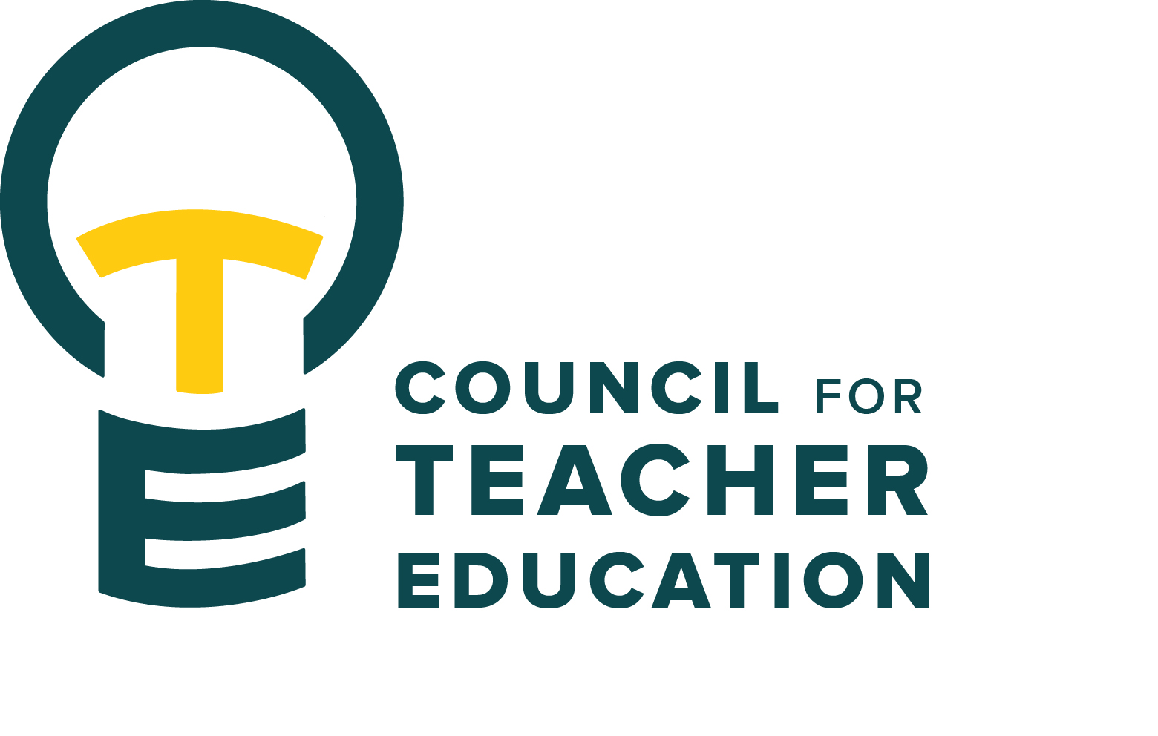

Council for Teacher Education
Meeting Minutes
April 28, 2026, 3:00-4:30 pm
Members Present: Joshua Altshuler, Aaron Baker, Sarah Boesdorfer, Gary Cates, Yojanna Cuenca-Carlino, Amanda Cullen, Cailyn Grieshaber, Amy Hurd, Sonia Kline, Allison Kroesch, Beth MacDonald, Deborah MacPhee, Sahana Mathan, Cassandra Mattoon, Michelle Maurer, Ishmael Neequaye, Monica Noraian, Oscar Nunez-Enriquez, Jay Percell, Rocio Rivadeneyra, Bert Stabler, Fatima Suhail, Victoria Sulewski, Mary Tackett, Janet Tulley, Michael Young, Ryan Brown for Bryan Zugelder

Absent: Tyler Ellison, Md Didar Hossain, Jeongae Kang, Kathy Mountjoy, Danielle Rankin, Marcus Russell, Rudo Tsemunhu

Guests: Peggy Finnegan-Boyes, Gary Higham, Sara Piotrowski

- Call to order: A. Kroesch called the meeting to order at 3:00 pm
- Roll Call: K. Brown conducted a roll call.
- Approval of minutes: March 24th minutes were approved. All in Favor.
- Information Items:
- STT Course Consideration Regarding Policy 2.1.9. (Amy Hurd) Student Teaching courses are now under the umbrella of their respective programs and no longer STT (TEC). They are not, however, to be counted toward the 55-credit unit maximum per major. Proposed policy language: “A major that awards the B.A., B.S, or B.S. in Education degree should not require more than 55 semester hours in the major department. (This limit does not apply to the B.F.A., the B.M., the B.M.E., the B.S. in Nursing, and the B.S.W. degrees.) The 55 hour cap does not include student teaching hours for teacher education programs.”
- STAR Act (Amy Hurd) The Student Transfer Achievement Reform Act requires that students transferring in with an associate degree must be able to complete their program degree at ISU within 60 hours unless an exception has been given. This includes student teaching. Programs should review articulation.

- Presentation from UEPPAR Subcommittee about the APIR (Sarah Boesdorfer & Peggy Finnegan-Boyes)
APIR Process
- UEPPAR revises surveys at the beginning of the Fall Semester.
- Surveys and instructions are sent to programs in October.
- Teacher Education Assessment Coordinator (Peggy) meets with individual programs when requested.
- Data workshops are held in early February.
- Surveys are due in late February.
- UEPPAR review process – one month to review
- UEPPAR feedback is distributed in late April.

UEPPAR recommendations
- Considering Goal 1 not to be Learning Outcomes focused
- Better communication of purpose of the APIR and use
- Be sure feedback from reviewers is useful to programs
- Some tweaks are needed to the form, both the reviewer and the program, to align better and give clarity.

- Presentation of the Student Excellence Awards (Mary Tackett & Sara Piotrowski, Student Advocacy & Interests subcommittee)
- Theme: Equity in Action: Creating pathways for all learning
- Of 16 submissions, the winners were: Mae Perkins, TCH ELED, Trinity Tokarz, TCH ELED, Lizze Paragi, TCH Bilingual ED, Vicky Chow, SED, Maxwell Mason, Technology ED.

- Pillars of Educator Excellence Canvas Modules, overview & updates (Becky Beucher, Efaw Center & Mary Tackett, Student Advocacy & Interests subcommittee). Allison presented some of the Canvas modules that are ready to go. The goal is to get universal information out to all stakeholders. Continuing to work on making the pillars match the modules. Reach out to Becky if interested in having students use them or if you want to use them.

- Thank you to the student representatives, thank you to the Dean's Representatives, thank you to the CTE members for this years’ service and engagement. A special thank you to those who have served their maximum terms and to those who are leaving CTE.

- Subcommittee Reports:
- Curriculum Committee: R. Rivadeneyra –The committee has reviewed 67 proposals this year. Rocio brought the following course revisions to a CTE membership vote at this meeting.
- Special Ed MSED (changing the sequence’s required courses to align with general sequence changes) Oscar Second, Allison abstains
- Special Ed and TCH: Multilingual graduate certificate (SED revised certificate to combine TCH and SED courses and programs) Jay Percell Second, Allison abstains
- Chemistry teacher ed: (Low enrollments in science teacher ed. All labs will be consolidated) Bert seconds
- Biological science teacher ed (changes so program and curricular align to standards) Amanda Cullen Second
- Advocacy Committee: J. Percell –They will share the survey QR code about “What it means to be a Redbird Educator “at the teacher appreciation event and continue collecting feedback. They will continue working on this project in the fall.
- Student (Advocacy &) Interest Committee: see Information Item above
- University Educator Preparation Program Assessment & Reporting Committee: see Information Item above
- Discussion Items:
- Review bylaws: subcommittee assignments, membership, and leadership. M. Noraian, looking back at the first year of CTE business under the new bylaws (membership guidelines, subcommittee consolidation, and other changes), seems things are going well. We will continue to review and request edits as needed. Members were asked to consider future leadership roles in CTE.
- Election: CTE chair, vice chair, secretary
- Allison remains in her second year as chair, and the one-year positions of vice chair and secretary are open.
- Allison motioned that Michael Young serve as vice chair after he expressed interest. All were in favor, and the motion carried.
- There are currently no volunteers for the secretary role. Members are asked to consider the possibility. An email will be sent, and a vote to confirm will follow.
- Action Items: None
- Legislative Updates: Check out the new CTE teams folder: Legislative Updates Council for Teacher Education (CTE) - Documents - Legislative Updates - All Documents
- Announcements and Last Comments: Have a great end to the semester & joyful summer. Please let Allison or Monica know if you are interested in a particular subcommittee assignment or leadership role (e.g., chair or co-chair).
- Adjournment: 4:10 p.m. Motion to adjourn by A. Kroesch

