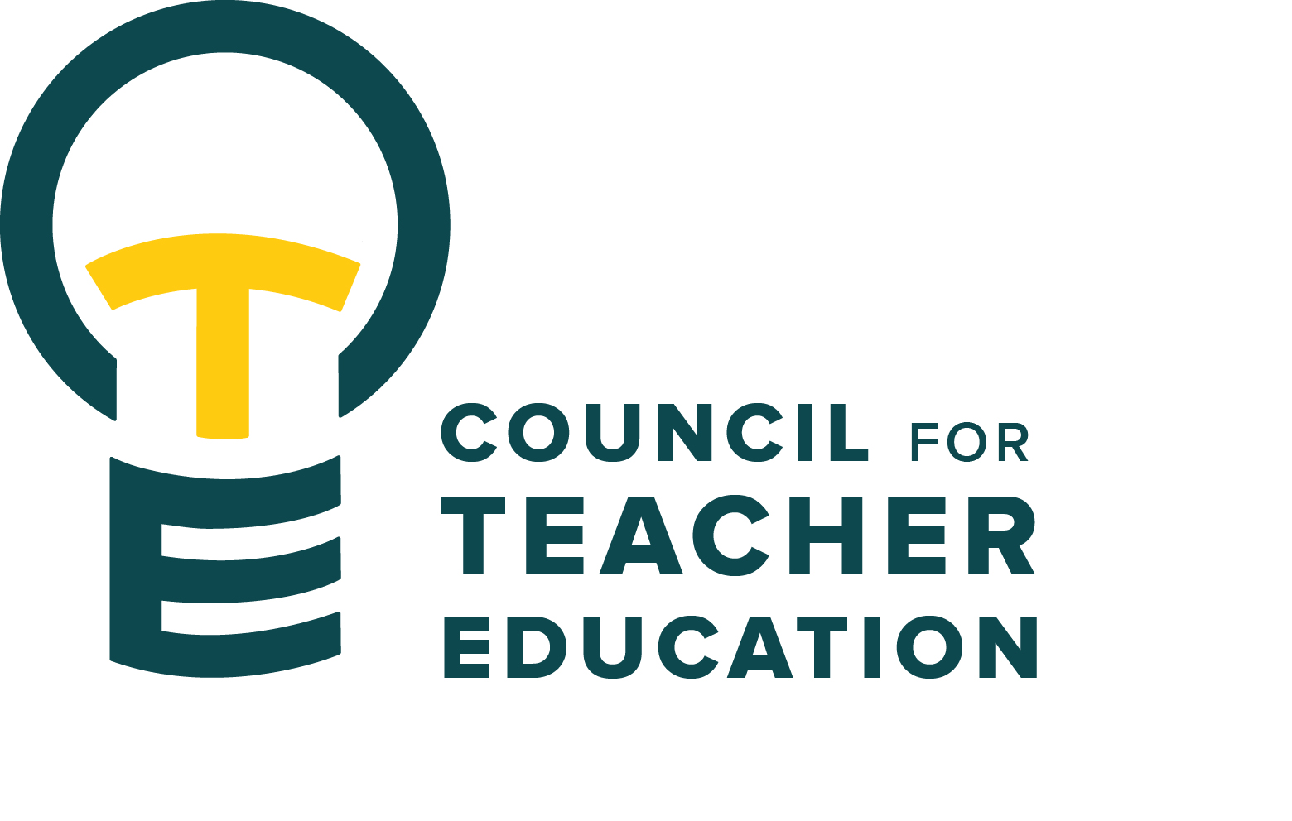

Council for Teacher Education
Meeting Minutes
August 25, 2026, 3:00-4:30 pm
Members Present: Joshua Altshuler, Aaron Baker, Nesrin Bakir, Josh Brown, Gary Cates, Amanda Cullen, Marko Dumancic, Mindy Ely, Kaitlyn Evans, Allison Kroesch, Beth MacDonald, Deborah MacPhee, Michelle Maurer, Melissa McClelland, Melissa McGraw, Monica Noraian, Rocio Rivadeneyra, Noelle Selkow, Bert Stabler, Fatima Suhail, Victoria Sulewski, Janet Tulley, Michael Young, Rachel Wolney, Bryan Zugelder

Absent: Cailyn Grieshaber, Sahana Mathan, Rudo Tsemunhu, Ken Wester (Newly Added Member)

Guests: Ryan Brown, Peggy Finnegan-Boyes, Gary Higham, Troy Hinkel, Cassandra Mattoon, Sara Piotrowski

- Call to order: 3:00 p.m. by A. Kroesch
- Roll Call: Complete per K. Brown
- Approval of minutes: April 28, 2026, minutes were approved via email shortly following the meeting.
- Self-Introductions were made by members and guests.
- Information Items:
- A TERB (Teacher Education Review Board) case was heard at the first Executive Committee meeting on August 18, 2026. Outcome was shared with the student and the student’s teacher education department. If there is a subsequent appeal by the student, it moves to the full CTE body for a hearing. For a hearing both sides would receive submitted materials to better prepare and understand the positions. It was discussed, Should the department and the student be given access to the other party’s materials (this does not happen at a TERB appeal)?
- A culture of continuous improvement (Bryan Zugelder) Dean Zugelder shared his thoughts about the competitive nature of higher education in today’s rapidly changing landscape. Pertinent issues include enrollment pressures, affordability, public confidence, workforce relevance, technology and AI disruption, student wellbeing, and political/regulatory pressures. President Tarhule’s message from the Academic Affairs Summit encouraged colleges to operate well, continuously improve, and build the capacities that define tomorrow’s university (institutional capacities). A formal process for employer, student, and partner feedback with data to inform decisions distinguishes Redbird Educators from others. To that end, Dean Zugelder strongly supports pursuing ongoing national accreditation at ISU.
- National Teacher Education Accreditation (AAQEP Introduction) – (Ryan Brown) In 2024, CTE decided not to seek renewal of CAEP accreditation, and its current standing will expire as of January 1, 2027. Ryan Brown, Monica Noraian, Allison Kroesch, Peggy Finnegan-Boyes, and Terry Jackson were tasked with investigating other options. They found AAQEP to be context-driven, supportive & developmental, formative & flexible, continuous improvement-focused, and rigorous without being prescriptive. AAQEP was described as follows:
- Four standards with multiple benchmarks
- Built to recognize different types of programs
- Standards 1 & 2 are documented with performance and outcome data (potentially like the current AIR process)
- Standards 3 & 4 are documented with descriptions and documentation of practices
The team felt AAQEP could integrate with existing systems.
If CTE members have feedback, it will be listened to.
AAQEP’s feedback process was seen as exceptional.
The timeline for full accreditation was discussed. It is estimated that it would take approximately 1 year to 18 months should accreditation be pursued.
- Lab School Clinical Process (Cassandra Mattoon) The Laboratory Schools have a new online “Instructor Request Form for Clinical Experiences” to request, document, and approve all clinicals taking place, including background check compliance. Found on Metcalf & U-High’s websites under the “Professors” link on the Teacher Education tab, a new form must be submitted each semester. Cassandra shared a walkthrough for completing the form, including tips on uploading class rosters.
- Subcommittee Work Time
- Subcommittee Reports: First Meeting No Reports
- Discussion Items: None
- Action Items: None
- Legislative Updates: None
- Announcements and Last Comments:
- Due to Construction, the TEC offices are closed, and staff are working across Degarmo. Please reach out by email.
- Lab School badges can be picked up in the Efaw Center.
- Adjournment: 4:30 p.m. by A. Kroesch

