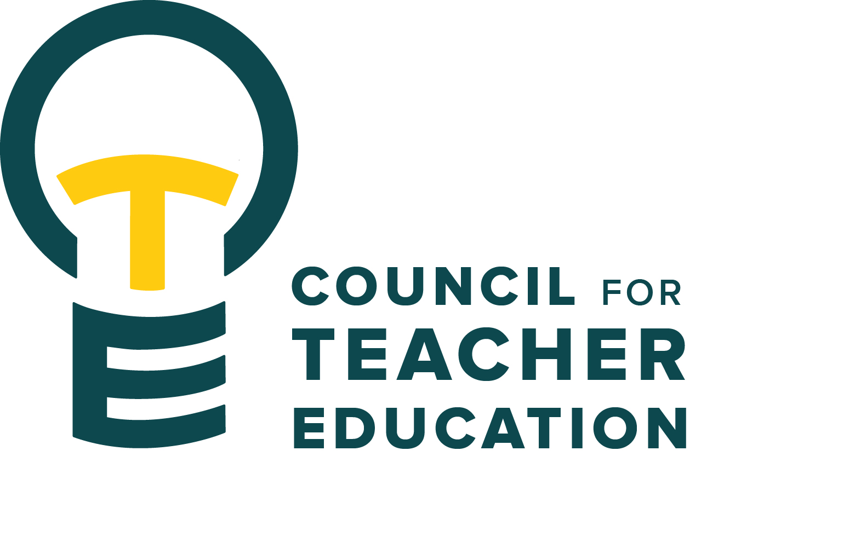

***Council for Teacher Education***

Meeting Minutes

August 26, 2025, 3:00-4:30 pm

**Members Present:** Joshua Altshuler, Aaron Baker, Sarah Boesdorfer, Gary Cates, Yojanna Cuenca-Carlino, Cailyn Grieshaber, Amy Hurd, Jeongae Kang, Sonia Kline, Allison Kroesch, Cassandra Mattoon, Michelle Maurer, Erin Mikulec, Kathy Mountjoy, Monica Noraian, Oscar Nunez-Enriquez, Jay Percell, Rocio Rivadeneyra, Mary Tackett, Rudo Tsemunhu, Janet Tulley, Michael Young, Bryan Zugelder

**Absent:** Amanda Cullen, Claudia Petrescu

**Guests:** Peggy Finnegan-Boyes, Gary Higham, Deborah MacPhee, Heidi Olsen

1. **Call to order:**  A. Kroesch called the meeting to order at 3:00 pm
2. **Roll Call**: Kelly Brown conducted a roll call.
3. **Approval of minutes: completed at the end of spring 2025 semester via email.**
4. **Information Items (addressed following member introductions):**
   1. **Updated CTE By Laws**  [Governance and Accreditation | Lauby Teacher Education Center | Illinois State](https://teachercenter.illinoisstate.edu/governance-reporting/) – a hard copy was distributed to members and uploaded to the Governance and Accreditation tab of the Lauby Center website, to the Teams folder, and to the members’ Outlook calendar invite.
   2. **Pillars & PER Process** [Professional Expectation Review (PER) | Lauby Teacher Education Center | Illinois State](https://teachercenter.illinoisstate.edu/faculty/per/) – a handout was provided which summarizes the information at this link. Pillars of Professional Excellence guidelines are used in conjunction with the PER process to help provide feedback to teacher candidates regarding their professional growth. PER replaces the Disposition Concerns process via the Kuali online platform. CTE Dean’s Reps are asked to share this and all CTE-related information with their colleges, and CTE members should help their programs with any questions they have and bring feedback to CTE membership. Thought should be given to syllabus language and utilization of the Efaw Center resources.
   3. **Appeal Process: TERB & CTE** [Teacher Education Appeal Process | Lauby Teacher Education Center | Illinois State](https://teachercenter.illinoisstate.edu/students/clinical/appeals/) –three unresolved PERs (or combination of PERs and former Disposition Concerns Assessments totaling three) will result in the stoppage of the teacher candidate’s progress in the Teacher Education program. They are, however, entitled to appeal through the Teacher Education Review Board (TERB). The process is detailed on the website at the link above. If the TERB appeal determines that the student should not continue in their program, and they desire to remain in teacher education, a second level of appeal can be initiated by the student for another opportunity to present their case. This appeal is taken to the full CTE.
5. **Subcommittees:** (A brief breakout session was held with the following instructions.)

* Introduce yourselves & review the subcommittee meeting time and location (are there edits needed?)
* Review the updated bylaws regarding subcommittee roles and responsibilities.
* Identify 2-3 Subcommittee goals & objectives for the year.
* Draft a timeline & needs list for successful implementation.
* Thinking CTE big picture, are there topics, themes, or guest suggestions for upcoming CTE meetings?

1. **University Educator Preparation Program Assessment & Reporting Committee:**S. Boesdorfer – They will look at the annual program review forms for any needed updates. Submissions will be reviewed in the spring and shared with CTE when completed.
2. **Curriculum Committee:** R. Rivadeneyra – Their charge will be to review curriculum proposals using a new system, “Coursedog”. Smaller changes get approved through the subcommittee internally, whereas larger/more impactful requests come to the full CTE membership for a vote.
3. **Advocacy Committee:** J. Percell – Their work will include staying current with trends in Teacher Education and communicating these issues to the membership. They discussed the varied resources available to them.
4. **Student (Advocacy &) Interest Committee:** M. Tackett – (Time change for meetings 3:30 – 4:30) The committee will manage the Student Excellence Award, determining the theme and seeing the process through to the award presentation. They will work to communicate with students the details of the new PER process. Additionally, they intend to promote student participation in CTE.
5. **Discussion Items:**
   1. If a member is not able to attend an upcoming meeting, they are asked to message Kelly Brown at kcbrow1@ilstu.edu.
   2. Allison and Monica are reaching out to departments to fill several membership spots for the upcoming year.
   3. Members should find ways to promote student participation & a CTE QR code flyer was provided.
   4. A door sign was provided to members, and they were asked to consider posting it in their departments. A part of a member’s charge is to increase awareness of CTE.
   5. E. Mikulec: suggested revising “Realizing the Democratic Ideal”
   6. B. Zugelder: Question regarding the section in the bylaws detailing their subcommittee charge, specifically the conceptual framework (NCATE language)
   7. A. Hurd: Is there a specific strategic plan for Teacher Education? There are strategic plans for both the University and the College of Education.
   8. R. Rivadeneyra: Should CTE consider revisiting the language “Realizing the Democratic Ideal,” which is currently on the COE website?
   9. E. Mikulec: Suggested reviewing the new campus budget model’s impact on Teacher Education (i.e.. gen-ed courses across campus that are needed for completion of teacher education programs).
6. **Action Items:** None
7. **Legislative Updates:** None
8. **Announcements and Last Comments:** Executive Committee & Subcommittees will meet next week, Tuesday, Sept. 2nd
9. **Adjournment:** 3:55 p.m. Motion to adjourn by A. Kroesch

**Next CTE Executive Board Meeting: September 2, 2025, 2-3 pm** **& CTE Subcommittee Meetings: Sept. 2, 2025, 3:00-4:30 pm**

**Advocacy Committee:** Co-Chairs Jay Percell & Bryan Zugelder(DEG 506A 3:00-4:30)

**Curriculum Committee:** Chair Rocio Rivadeneyra (DEG 304 3:00-4:30)

**Student (Advocacy &) Interests Committee:** Co-Chairs Mary Tackett & Sara Piotrowski (DEG 504 3:30-4:30)

**University Educator Preparation Program Assessment & Reporting Committee:**Chair Sarah Boesdorfer (DEG 551 3:00-4:30)

**Next CTE Meeting:  September 23, 2025, 3:00-4:30 pm**

**2025-2026 CTE & COMMITTEE MEETING SCHEDULE**

|  |  |  |
| --- | --- | --- |
| **CTE** DEG 551 | **2025 Exec & Subcommittees** | **2026 Exec & Subcommittees: continued** |
| Aug. 26 | Aug. 19 | Jan. 6 (No Meeting) |
| Sept. 23 | Sept. 2 | Jan. 20 |
| Oct. 28 | Sept. 16 | Feb. 3 |
| Nov. 18 | Oct. 7 | Feb. 17 |
| Dec. 9 | Oct. 21 | Mar. 3 |
| Jan. 27 | Nov. 4 | Mar. 17 |
| Feb. 24 | Nov. 18 (No Meeting) | Apr. 7 |
| Mar. 24 | Dec. 2 | Apr. 21 |
| Apr. 28 | Dec. 16 (No Meeting) |  |