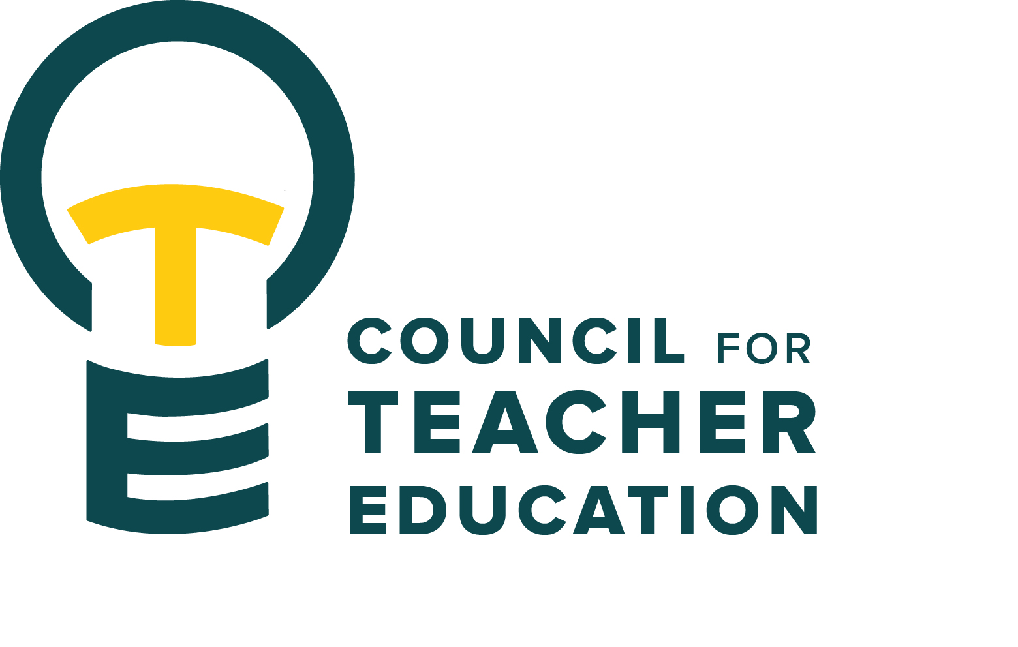

Council for Teacher Education
Meeting Minutes
September 22, 2026, 3:00-4:30 pm
Members Present: Joshua Altshuler, Aaron Baker, Nesrin Bakir, Josh Brown, Gary Cates, Amanda Cullen, Marko Dumancic, Kaitlyn Evans, Allison Kroesch, Kristina Falbe for Deborah MacPhee, Michelle Maurer, Melissa McClelland, Melissa McGraw, Monica Noraian, Rocio Rivadeneyra, Noelle Selkow, Bert Stabler, Fatima Suhail, Victoria Sulewski, Janet Tulley, Ken Wester, Rachel Wolney, Michael Young, Bryan Zugelder

Absent: Mindy Ely, Cailyn Grieshaber, Beth MacDonald, Sahana Mathan, Rudo Tsemunhu

Guests: Angela Bonnell, Ryan Brown, Gary Higham, Troy Hinkel, Heidi Olsen, Philip Pulley

- Call to order: 3:00 p.m. by A. Kroesch
- Roll Call: Complete per K. Brown, quorum present
- Approval of minutes: August 25, 2026, minutes were approved by all members present
- Welcome & introductions to new CTE members: Ken Wester is joining the council from the Physics Education program.
- Information Items:
- Academic Senate Chair Angela Bonnell provided an overview. Formed in 1970, when the Student Caucus merged with the Faculty Senate, it is the primary governing body that makes recommendations to the President. There is currently a 3-to-2 faculty-to-student ratio. CTE is one of 27 committees working under the Academic Senate.
The following are items of interest for the Academic Senate this year.
• The Baccalaureate Degree Policy is under review. A vote had been anticipated, but it may be postponed until the Senate's next meeting. If approved in its current form, several teacher education programs could be out of compliance because of variation in the number of credit hours associated with student teaching.
• The Appropriate Use Policy, which has not been updated in more than 15 years, is also scheduled for review.
• The Code of Ethics, Code of Student Conduct, and policies related to the use of electronic equipment for surveillance purposes are overdue for review and are expected to be addressed this year.
• Revisions to ASPT policies to align with the collective bargaining agreement have been completed by the University Review Committee and forwarded to the Academic Senate for review.
- Troy Hinkel & Bryan Zugelder – ISBE Updates & Information: Troy shared information about Policy Act 104-0795, which would amend the school code regarding continuing education coursework used for salary increases. Graduate programs that lead to licensure or include internships or student teaching should ensure that appropriate documentation is maintained.
Bryan shared information from the IL Deans for Public Colleges of Education meeting, including a presentation on residency and apprenticeship policy with possible funding opportunities for paid or subsidized student experiences in schools. The Illinois Teacher Performance Assessment (IL TPA) is being drafted and is expected to be offered for feedback soon. There was also discussion regarding potential reporting based on candidate performance, including where program graduates are employed and other follow-up information after graduation.
- Subcommittee Reports:
- Curriculum (Rocio Rivadeneyra): There are three curriculum changes pending approval. No modifications require full council approval.
- Advocacy (Gary Cates): The committee will continue to develop and revamp the survey regarding “What it means to be a Redbird Educator” and how it relates to the established “Democratic Ideal”. They will focus on communication with the Lauby Teacher Education Center as well as the Milner Library.
- Student Advocacy & Interests (Amanda Cullen): They are working to recruit students to their committee; collecting data regarding awareness and understanding of PERs, while promoting relevant Efaw Center programming; and reviewing the Student Excellence Award process. A new evaluation rubric is being developed.
- University Educator Preparation Program Assessment & Reporting (Joshua Altshuler): APIR (Annual Program Improvement Review) support continues. A discussion regarding switching from digital format to in-person reviews was held. There was significant support for in-person reviews. The committee also discussed the potential adoption of AAQEP accreditation and its possible impact on the APIR process.
- Discussion Items: AAQEP Presentation and Discussion (Ryan Brown): National accreditation through CAEP will expire at the end of the current calendar year. AAQEP (the Association for Advancing Quality in Educator Preparation) is being considered as an alternative. AAQEP is made up of four standards
Student Related
- Standard 1 focuses on the candidate completer’s foundational knowledge and skills
- Standard 2 focuses on their professional growth and adaptability
Process/Ecosystem Related
- Standard 3 focuses on quality control/assurance
- Standard 4 on Program engagement in system improvement
Ryan has reached out to Morehead State University, SUNY New Paltz, and Portland State University for their feedback on the program. The opinions expressed so far are that AAQEP is a far superior accrediting body to other continuous improvement vehicles.
Discussion emphasized flexibility in how programs identify and measure outcomes. The APIR process may support AAQEP Standard 3, and the Lauby Teacher Education Center, in collaboration with Ryan Brown, would help facilitate the accreditation process. The Illinois TPA was also discussed as a potential central assessment rather than a program-specific measure.
A question was raised about the role of CTE in both recommending and compiling the report. The Council is expected to vote at a future meeting on whether to recommend pursuing AAQEP accreditation. If recommended, the proposal would move to the Dean and Provost. The next step would be AAQEP membership, which would provide access to additional resources.
A question was posed about funding. The College of Education would cover accreditation costs, estimated at $10,000 annually, plus about $3,000 for the initial site visit and $7,000 for the in-person visit associated with the 7-year cycle. AAQEP also requires annual reporting and ongoing progress monitoring. (AAQEP is cheaper than CAEP)
CTE members are asked to share with their programs, discuss, and bring their thoughts back to CTE.
- Action Items: None
- Legislative Updates: None
- Announcements and Last Comments:
- A time capsule has been discovered while repairs to the Lauby Center have been taking place. A reveal and celebration will be held on September 30th at 2 p.m. A new time capsule will be placed; however, construction timelines necessitate a quick turnaround. Council members who have items to add should bring them to Monica tomorrow.
- Adjournment: 4:18 p.m. by A. Kroesch

CTE Executive Board Meetings DEG 504 2:00-3:00 pm & CTE Subcommittee Meetings DEG 551 3:00-4:30 pm
Advocacy Committee: (DEG 504 3:00-4:30)
Curriculum Committee: (DEG 304 3:00-4:30)
Student (Advocacy &) Interests Committee: (DEG 039 3:00-4:30)
University Educator Preparation Program Assessment & Reporting Committee: (DEG 551 3:00-4:30)
CTE Meetings 3:00-4:30 pm

2026-2027 CTE & COMMITTEE MEETING SCHEDULE
CTE DEG 551 | 2026 Exec & Subcommittees | 2027 Exec & Subcommittees: continued
Oct. 27 | Oct. 6 | Jan. 5 (No Meeting)
Nov. 17 | Oct. 20 | Jan. 19
Dec. 8 | Nov. 3 | Feb. 2
Jan. 26 | Nov. 17 (No Meeting) | Feb. 16
Feb. 23 | Dec. 1 | Mar. 2
Mar. 23 | Dec. 15 (No Meeting) | Mar. 16
Apr. 27 |  | Apr. 6
 |  | Apr. 20

