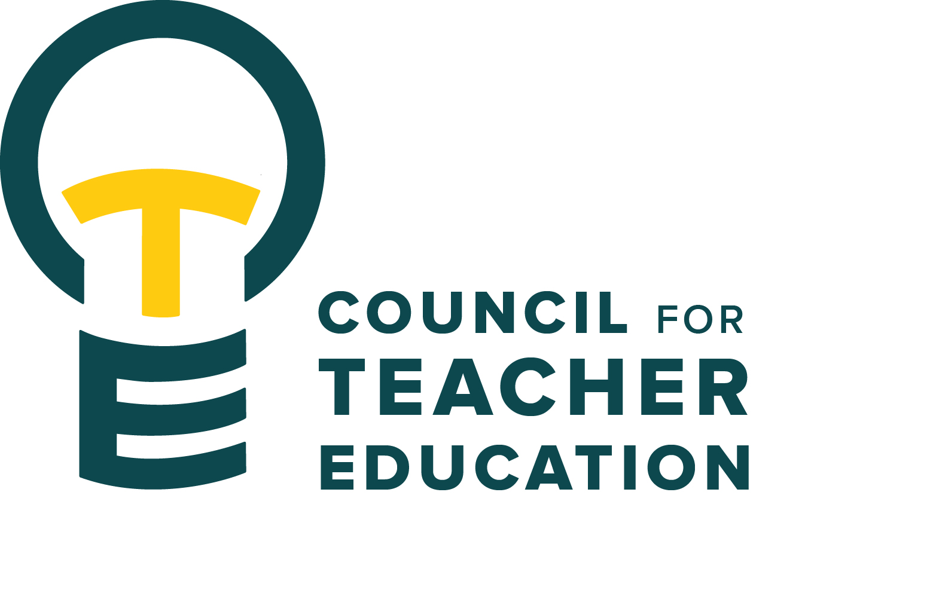

Council for Teacher Education
Meeting Minutes
December 9, 2025, 3:00-4:30 pm
Members Present: Joshua Altshuler, Gary Cates, Yojanna Cuenca-Carlino, Amanda Cullen, Md Didar Hossain, Amy Hurd, Jeongae Kang, Allison Kroesch, Beth MacDonald, Cassandra Mattoon, Michelle Maurer, Ishmael Neequaye, Gary Higham for Monica Noraian, Jay Percell, Rocio Rivadeneyra, Mary Tackett, Janet Tulley, Michael Young, Ryan Brown for Bryan Zugelder

Absent: Aaron Baker, Sarah Boesdorfer, Tyler Ellison, Cailyn Grieshaber, Sonia Kline, Sahana Mathan, Erin Mikulec, Kathy Mountjoy, Oscar Nunez-Enriquez, Danielle Rankin, Marcus Russell, Bert Stabler, Rudo Tsemunhu

Guests: Becky Beucher, Troy Hinkel, Jena Hobbs

- Call to order: A. Kroesch called the meeting to order at 3:03 pm
- Roll Call: K. Brown conducted a roll call.
- Approval of minutes: November 18th minutes approved unanimously with no abstentions
- Information Items:
  - None
- Subcommittees Reports:
- Curriculum Committee: R. Rivadeneyra – Reviewed 11 proposals. Approved 2 new TCH courses and revisions on 2 CSD courses. 4 courses were sent back for clarification. The following program revisions were brought forward for a full CTE vote.
  - Specialist in School Psychology (SSP) – R. Rivadeneyra motioned, J. Percell seconded, passed with one abstention
  - Special Education MSED (new sequence in Deaf and Hard of Hearing) – R. Rivadeneyra motioned, A. Cullens seconded, motion passed unanimously
  - Geology (BS, which includes revisions to the Earth and Space Science Secondary Ed sequence) – R. Rivadeneyra motioned, M. Tacket seconded, motion passed unanimously
- Advocacy Committee: J. Percell – See Discussion Item “a” below.
- Student (Advocacy &) Interest Committee: M. Tackett – Met with Becky Beucher, Director of the Efaw Center, to discuss PERs effects on the Center. The upcoming focus will be on this year’s CTE student excellence award.
- University Educator Preparation Program Assessment & Reporting Committee: J. Altshuler – The committee is preparing for the APIR reviews.
- Discussion Items:
  - Sharing ideas about what it means to be a Redbird Educator – Members broke into groups to discuss the core values and characteristics of ISU teacher candidates using the following prompts.
  - What characteristics or attributes do we expect to see in our Redbird Teacher/Educator graduates?
  - What coursework, projects, or experiences do ISU Teacher Education programs use to teach these values?
  - Who are the thinkers/authors/scholars/theorists you use to support the development of these attributes?
  - Are there national organizations or associations that support or inform the values you hope to see in our future teachers/educators?
  - Suggestions for future meeting topics, areas of question, concern, or interest. –
- Action Items: None
- Legislative Updates: None
- Announcements and Last Comments:
- Adjournment: 4:00 p.m. Motion to adjourn by A. Kroesch

Next CTE Executive Board Meeting: January 20, 2026, 2-3 pm & CTE Subcommittee Meetings: Jan 20, 2026, 3:00-4:30 pm
Advocacy Committee: Co-Chairs Jay Percell & Bryan Zugelder (DEG 506A 3:00-4:30)
Curriculum Committee: Chair Rocio Rivadeneyra (DEG 304 3:00-4:30)
Student (Advocacy &) Interests Committee: Co-Chairs Mary Tackett & Sara Piotrowski (DEG 504 3:30-4:30)
University Educator Preparation Program Assessment & Reporting Committee: Chair Sarah Boesdorfer (DEG 551 3:00-4:30)

Next CTE Meeting: January 27, 2026, 3:00-4:30 pm

2025-2026 CTE & COMMITTEE MEETING SCHEDULE
CTE DEG 551 | Exec & Subcommittees | Exec & Subcommittees: continued
Jan. 27 | Dec. 16 (No Meeting) | Mar. 3
Feb. 24 | Jan. 6 (No Meeting) | Mar. 17
Mar. 24 | Jan. 20 | Apr. 7
Apr. 28 | Feb. 3 | Apr. 21
 | Feb. 17

